Curriculum policy
Milestone Meadow

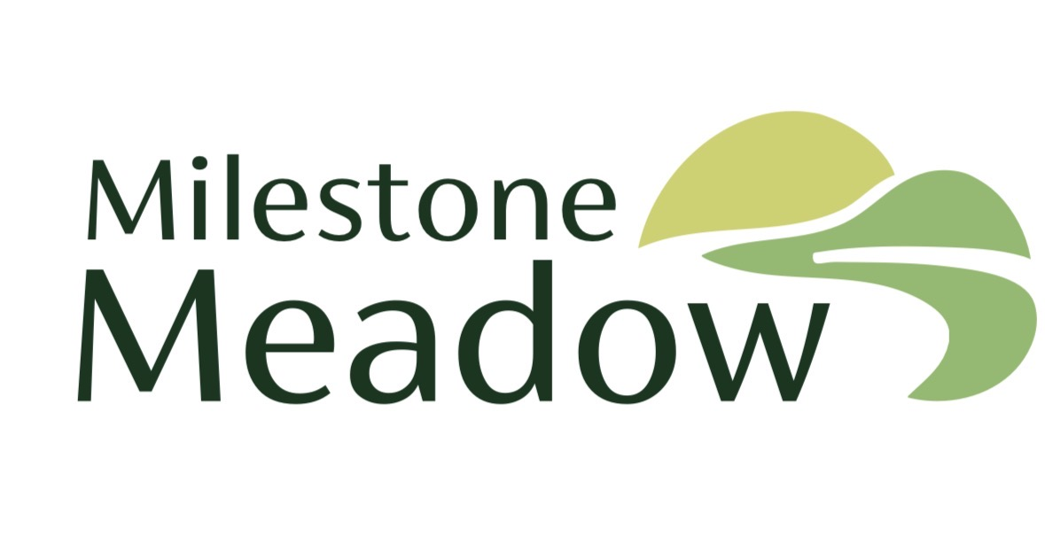

Approved by: | Angela Masters | Date: 01.01.2026
Last reviewed on: | 01.01.2026
Next review due by: | 01.01.2027

Contents
1. Purpose 3
2. Scope 3
3. Curriculum Intent and Aims 3
4. Curriculum Structure 4
5. Personalised and Individualised Learning 5
6. Teaching and Learning Approaches 6
7. Assessment and Progress 6
8. Monitoring, Evaluation and Review 7
9. Inclusion and Equality 7
10. Review of Policy 7

1. Purpose
The purpose of this policy is to outline how Milestone Meadow Alternative Provision delivers a broad, balanced, and highly personalised curriculum that meets the individual needs of all pupils, particularly those with Special Educational Needs and Disabilities (SEND). The curriculum is designed to support pupils who may have experienced barriers to learning within mainstream settings and to promote progress academically, socially, emotionally, and developmentally.
Our curriculum aims to re-engage pupils with learning, build confidence and resilience, and support positive outcomes through a nurture-based, trauma-informed approach. It reflects statutory guidance while remaining flexible and responsive to the complex needs of our cohort.

2. Scope
This policy applies to:
- All pupils attending Milestone Meadow Alternative Provision
- All teaching staff, support staff, and external professionals contributing to curriculum delivery
- Senior leaders responsible for curriculum oversight and quality assurance
The policy covers curriculum intent, implementation, assessment, monitoring, and review.

3. Curriculum Intent and Aims
Milestone Meadow’s curriculum is underpinned by the belief that all pupils are entitled to a high-quality education, regardless of prior experience, need, or starting point. We recognise that many pupils attending alternative provision have experienced disrupted learning, unmet needs, or social and emotional challenges, and therefore require a curriculum that prioritises wellbeing alongside academic progress.
Our curriculum intent is to provide a carefully sequenced, nurturing, and aspirational learning experience that supports pupils to re-engage with education, develop confidence, and make meaningful progress. The curriculum is designed to be flexible and responsive, adapting to the evolving needs of pupils while maintaining high expectations for learning and personal development.
Our curriculum is:
- Nurture-based, placing emotional security, positive relationships, and wellbeing at the centre of learning.
- Personalised, ensuring learning is tailored to pupils’ individual needs, strengths, interests, and EHCP outcomes.
- Inclusive and accessible, removing barriers through reasonable adjustments, differentiated teaching, and supportive environments.
- Experiential and meaningful, enabling pupils to learn through practical activities, exploration, and real-life contexts.
Our key aims are to:
- Deliver a personalised curriculum aligned with each pupil’s Education, Health and Care Plan (EHCP) and assessed needs
- Support pupils to develop core skills in literacy, numeracy, and communication at an appropriate pace
- Promote social, emotional, and mental health development, including emotional regulation, resilience, and self-awareness
- Develop independence, life skills, and functional learning to support everyday living
- Rebuild positive attitudes towards learning and school through success, encouragement, and meaningful experiences
- Prepare pupils for reintegration, transition to other provisions, or progression to the next stage of education
- Foster curiosity, engagement, creativity, and a sense of achievement across all areas of learning

4. Curriculum Structure
The curriculum at Milestone Meadow is structured to ensure breadth, balance, and progression while allowing flexibility to meet individual needs. Curriculum pathways are informed by pupils’ EHCPs, assessments, and developmental stages rather than chronological age.
Learning is organised to support consistency and predictability, while remaining adaptable to pupils’ emotional readiness and engagement. Timetables may include a balance of academic learning, therapeutic approaches, outdoor learning, and time for regulation and reflection.
Core Areas of Learning
All pupils access the following core areas of learning, adapted to meet their individual needs and abilities:
- Literacy – including phonics, reading, writing, speaking and listening, and functional literacy skills that support communication and independence.
- Numeracy – including number recognition, calculation, problem-solving, reasoning, and functional maths relevant to everyday life.
- Communication and Interaction – focusing on speech, language, communication skills, and the use of alternative or augmentative communication systems where appropriate.
- Personal, Social and Emotional Development (PSED) – supporting emotional literacy, relationship-building, self-regulation, behaviour understanding, and wellbeing.
Additional Areas of Learning
Where appropriate, pupils also access a range of wider curriculum opportunities, including:
- Science, delivered through practical, exploratory, and sensory-based learning
- Creative Arts, including art, music, and drama, to promote expression and creativity
- Physical Education and movement, supporting physical development and regulation
- Outdoor learning and forest-school-style activities, promoting confidence, teamwork, and connection with the environment
- Life skills and independence, such as personal care, routines, money awareness, and community skills
- PSHE and citizenship, supporting understanding of relationships, rights, responsibilities, and British values
The curriculum may draw on elements of the EYFS Framework, National Curriculum, and preparation for adulthood outcomes, depending on pupil need rather than chronological age.:
- Literacy – including phonics, reading, writing, speaking and listening, and functional literacy
- Numeracy – including number, calculation, problem-solving, and functional maths
- Communication and Interaction – speech, language, communication skills, and alternative/augmentative communication where appropriate
- Personal, Social and Emotional Development (PSED) – emotional literacy, relationships, self-awareness, and behaviour regulation
Additional Areas of Learning
Where appropriate, pupils also access:
- Science (practical and exploratory)
- Creative Arts (art, music, drama)
- Physical Education and movement
- Outdoor learning and forest-school-style activities
- Life skills and independence (e.g. personal care, routines, money awareness)
- PSHE and citizenship
The curriculum may draw on elements of the EYFS Framework, National Curriculum, and preparation for adulthood outcomes, depending on pupil need rather than chronological age.

5. Personalised and Individualised Learning
Personalisation is central to the curriculum at Milestone Meadow. We recognise that pupils arrive with diverse experiences, needs, and learning profiles, and therefore require highly individualised approaches to ensure success.
- All pupils have an individual learning plan linked directly to their EHCP outcomes or clearly identified needs.
- Curriculum pathways are personalised, with clear short-, medium-, and long-term targets that are regularly reviewed.
- Teaching is adapted through differentiation, scaffolding, and multisensory approaches to support different learning styles and needs.
- Learning is delivered through a combination of whole-group, small-group, and 1:1 teaching, depending on individual need and readiness.
- Pupils’ interests, strengths, and preferred learning approaches are actively used to enhance motivation, engagement, and confidence.
- Reasonable adjustments are made to ensure accessibility for all learners, including adaptations to the environment, resources, communication methods, and expectations.
Personalised learning plans are reviewed regularly in partnership with parents, carers, and external professionals to ensure provision remains effective, relevant, and responsive to pupils’ changing needs.

6. Teaching and Learning Approaches
Teaching and learning at Milestone Meadow Alternative Provision is designed to meet the complex and diverse needs of pupils who may have experienced disrupted education, trauma, anxiety, or barriers to engagement in mainstream settings. Our approach prioritises emotional safety, trust, and consistency as the foundations for effective learning.
Teaching at Milestone Meadow is underpinned by:
- Trauma-informed and attachment-aware practice, recognising the impact of adverse childhood experiences on behaviour, emotional regulation, and learning.
- A strong focus on positive relationships, with staff acting as consistent, trusted adults who model respect, empathy, and effective communication.
- Clear routines and predictable structures, which reduce anxiety, promote emotional security, and support pupils to engage confidently with learning.
- High adult-to-pupil ratios, allowing for personalised support, flexible responses, and early intervention.
- The use of visual supports, practical resources, and sensory regulation strategies, including visual timetables, now/next boards, sensory breaks, calm spaces, and regulation tools.
Learning experiences are carefully planned to be active, practical, and meaningful, enabling pupils to make connections between learning and real-life contexts. Teaching is flexible and responsive, allowing staff to adapt pace, content, and delivery based on pupils’ emotional readiness, engagement levels, and individual needs. Opportunities for repetition, overlearning, and consolidation are embedded to support confidence, independence, and long-term retention.
Any substances are in a closed room behind a locked door in a cabinet. Any hazardous products are disposed of in accordance with specific disposal procedures.
Emergency procedures, including procedures for dealing with spillages, are displayed near where hazardous products are stored and in areas where they are routinely used.

7. Assessment and Progress
Assessment at Milestone Meadow is purposeful and holistic, used to inform teaching, identify progress, and plan next steps rather than to compare pupils against age-related expectations. Given the wide range of starting points, progress is measured against individual baselines and personalised targets.
Assessment includes:
- Baseline assessments on entry, drawing on previous school records, professional reports, observation, and discussions with parents and carers.
- Ongoing formative assessment, including observation, questioning, work scrutiny, and monitoring engagement, behaviour, and emotional regulation.
- Termly summative assessments, measuring progress against personalised learning targets and EHCP outcomes.
- Specialist assessments where appropriate, including communication, sensory processing, and SEMH assessment tools.
Progress is measured holistically and may include academic attainment, communication skills, emotional regulation, engagement with learning, attendance, independence, and readiness for transition. Assessment information is shared with parents, carers, and commissioning bodies as appropriate and is used to review provision, adapt curriculum pathways, and ensure pupils receive the support they need to succeed.

8. Monitoring, Evaluation and Review
The quality and impact of the curriculum at Milestone Meadow are monitored systematically to ensure it continues to meet the needs of pupils and aligns with statutory guidance and best practice.
Monitoring and evaluation activities include:
- Termly curriculum reviews led by the Headteacher/SENCo to evaluate coverage, progression, and impact.
- Lesson observations and learning walks, focusing on engagement, relationships, differentiation, and consistency of practice.
- Regular review of assessment data and pupil progress, including progress towards EHCP outcomes.
- Pupil voice, gathered through discussion, observation, and developmentally appropriate feedback.
- Parental and carer feedback, recognising the importance of strong partnerships.
- An annual curriculum audit, ensuring compliance with statutory requirements and continuous improvement.
Findings from monitoring activities inform staff training and professional development, curriculum refinement, and strategic planning to ensure high-quality provision for all pupils.

9. Inclusion and Equality
Milestone Meadow Alternative Provision is committed to ensuring equality of opportunity for all pupils. Inclusion is central to our ethos and underpins all aspects of curriculum design and delivery.
The curriculum:
- Promotes inclusion, respect, tolerance, and diversity
- Is free from discrimination and prejudice
- Is adapted to meet individual needs regardless of gender, ethnicity, disability, language, or background
Reasonable adjustments are made to ensure all pupils can access learning. Staff work closely with families and external professionals to remove barriers and promote positive outcomes. Differences are valued and celebrated, supporting pupils to develop self-esteem, confidence, and respect for others.

10. Review of Policy
This policy will be reviewed annually or sooner if there are significant changes to statutory guidance, inspection frameworks, pupil needs, or the structure of the provision. Reviews will be led by the Headteacher/SENCo and informed by monitoring outcomes, staff feedback, and pupil progress.

